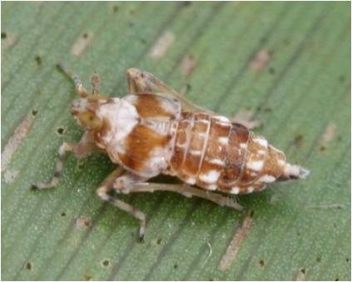

**Enlarged picture of Adult *Megamelus scutellaris***

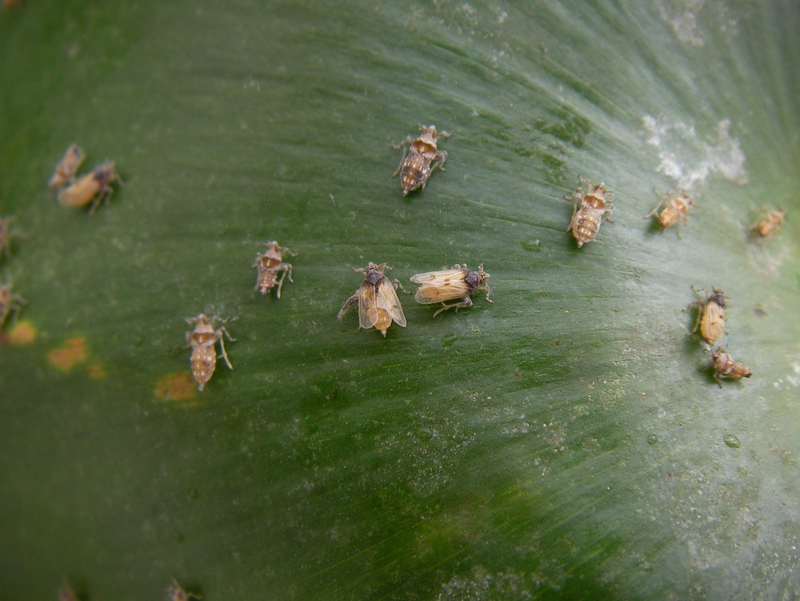

**Englarged picture of three different life stages of *Megamelus scutellaris*. Macropterous adults (winged), Brachypterous adults (without wings), and large nymph stage feeding on *Eichhornia Crassipes* (Water Hyacinth).**